
Bahria University, Lahore Campus
Department of Computer Science
Lab Journal 12
(Fall 2025)

Course: | Introduction to Data Science - Lab | Date: _______________
Course Code: | CSL-487 | Max Marks: 20
Faculty’s Name: | Mr. Muhammad Umar Tariq

Name: Khawaja Fahad Zia Enroll No: 03-134221-057 Class: BSCS6A

Objective(s):
Upon completion of this lab session, learners will be able to:
- Generate concise and meaningful summaries from long text using a pretrained model.
- Create coherent and creative text continuations from a given prompt using a language model.
- Build an interactive chatbot using the Gemini API with secure key handling and system prompt integration.
- Evaluate generated outputs for accuracy, coherence, creativity, and alignment with instructions.
- Experiment with prompts and model parameters to control output quality and behavior.

Lab Tasks:

Lab Task 1 — Text Summarization
Objective
Students will implement, analyze, and evaluate abstractive summarization using a pretrained Transformer model. The focus is not only on generating summaries but also on understanding model limitations, parameter effects, and the quality of generated outputs.

Task Requirements
1. Load and Configure the Model
Use the BART Large CNN summarization model.

from transformers import pipeline
summarizer = pipeline ("summarization", model="facebook/bart-large-cnn")

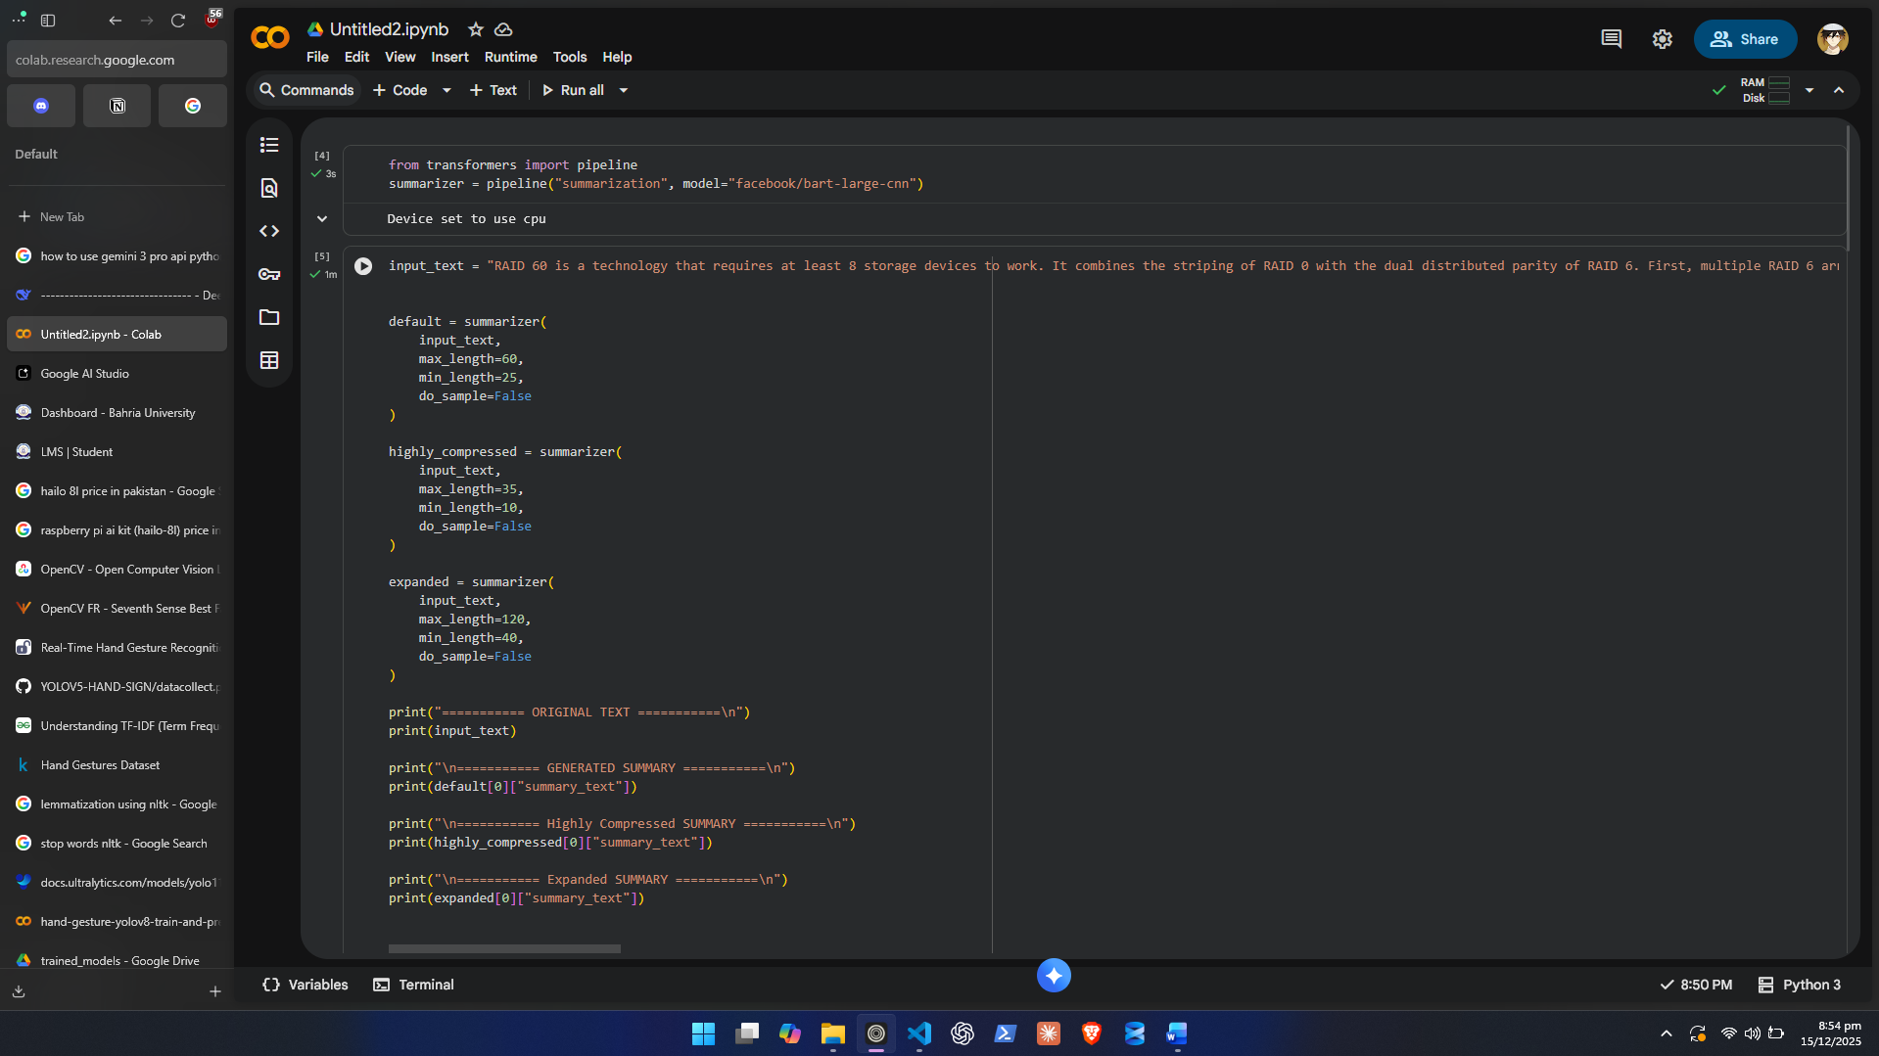

2. Input Text
Choose or write a complex paragraph of 8–12 sentences containing:
- Multiple ideas
- Some technical phrasing
- At least one comparative or analytical sentence
- Slight redundancy (so the model has something to compress)

3. Generate Three Summaries
You must generate three different summaries, each using different parameter configurations:
- Default Summary
  - max_length=60
  - min_length=25
- Highly Compressed Summary
  - max_length=35
  - min_length=10
- Expanded Summary
  - max_length=120
  - min_length=40

Your code example:
summary_default = summarizer (text, max_length=60, min_length=25)
summary_short = summarizer (text, max_length=35, min_length=10)
summary_long = summarizer (text, max_length=120, min_length=40)

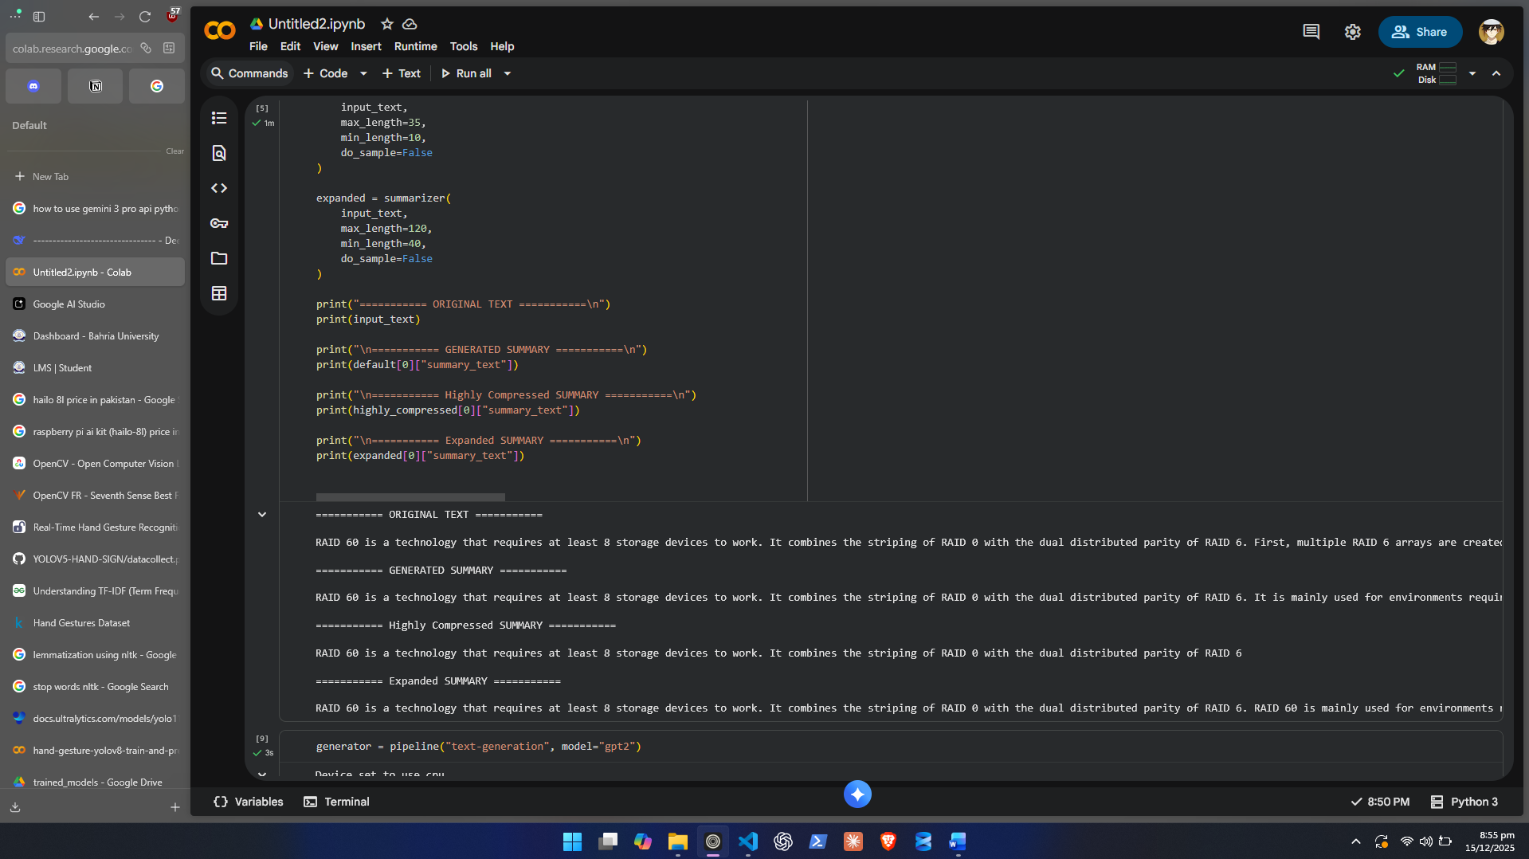

4. Analytical Evaluation
Write a detailed evaluation (8–10 sentences) discussing:
- Which summary preserves the main idea most accurately?

Default and Expanded both.

- Which summary loses important context and why?
Highly compressed one loses more context as it has a length limit and cuts off.

- How parameter changes affect the summarizer’s behavior.
The summarizer cuts off in the middle of output.

- Where the summarizer makes mistakes (hallucination, missing points, oversimplification).
It doesn’t make mistakes just cuts off.

- Whether the model captured relationships between ideas.
It did capture the relationship.

- Which version is closest to a “human-written” summary.
Both default and expanded ones.

You must demonstrate understanding of how summarization model’s function.

5. Optional
Run the same text through any second summarization model (T5, Pegasus, or LLaMA-based) and compare performance.

Lab Task 2 — Text Generation / Creative Story Modeling
Objective
Students will generate creative story continuations using a GPT-style language model and critically analyze the model’s narrative coherence, creativity, and limitations.

Task Requirements
1. Load & Configure the Model
Use the GPT-2 text-generation pipeline:

from transformers import pipeline
generator = pipeline ("text-generation", model="gpt2")

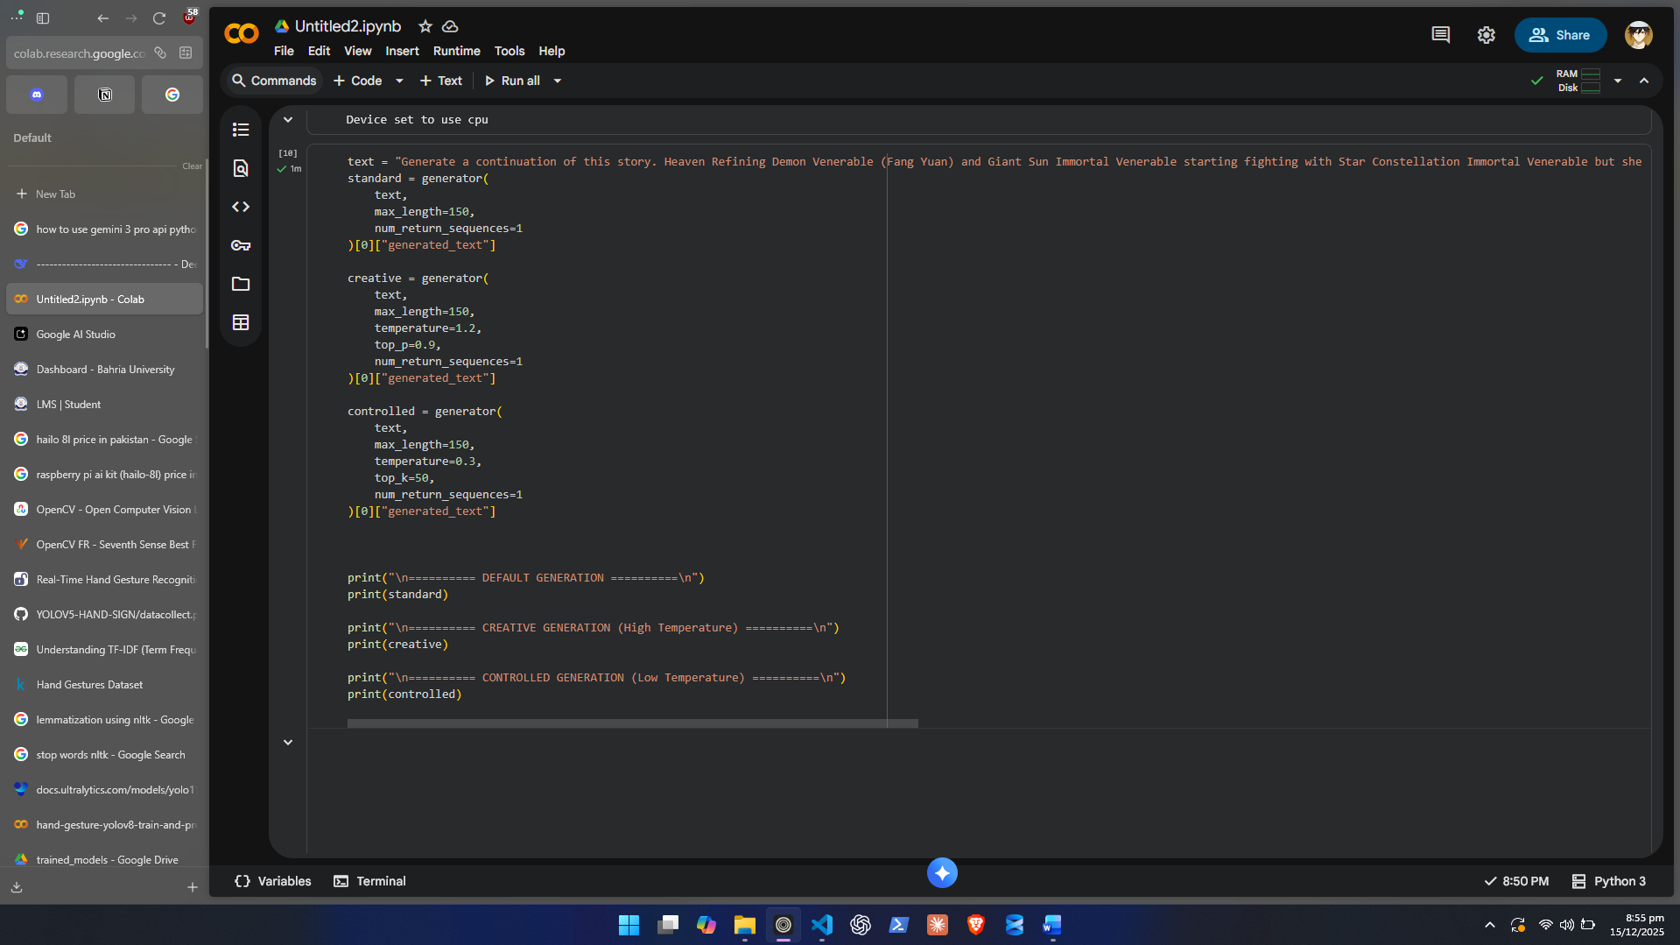

2. Create a Complex Prompt
Write a 1–2 sentence prompt that must include:
- A character (e.g., a scientist, detective, child, robot, etc.)
- A setting (fantasy world, futuristic city, ancient ruins, etc.)
- A conflict or tension hint
(e.g., “...but something felt wrong”, “...until a mysterious signal appeared.”)

Simple prompts are NOT allowed.
Your prompt needs enough complexity for meaningful generation.

3. Generate Multiple Continuations
Produce three different story continuations for the same prompt:

- Default Generation
  - max_length=150
- Creative / Random Variation
  - Use a higher sampling temperature
  - Example:
  - generator (prompt, max_length=150, temperature=1.2, top_p=0.9)
- Controlled / Less Random Version
  - Lower temperature
  - Example:
  - generator (prompt, max_length=150, temperature=0.3, top_k=50)
Each continuation must be 100–150 words.

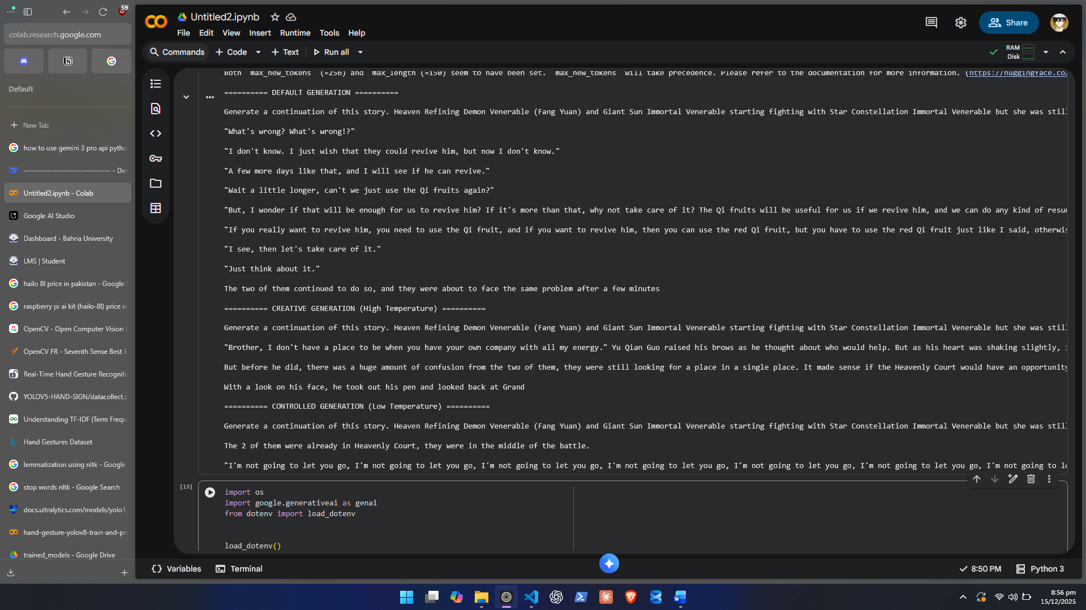

4. Deep Analysis (Mandatory)
Write a 10–12 sentence analytical reflection addressing:
- How does temperature affect creativity?
Higher temperature one started to describe the situation and surroundings as well. The default one was only giving a conversation. Still none make any sense.

- Which version is the most coherent?
None of them are coherent.

- Did the model introduce hallucinated facts or contradictions?
The generated texts don’t make any sense.

- Did the story stay aligned with your original prompt?
The generated texts don’t make any sense.

- Which continuation shows the strongest world-building?
The creative one but the generated texts don’t make any sense.

- Which feels closest to a human writer’s style?
Creative one.

- Was there any repetitive or nonsensical output?
Controlled one was repetitive and none of the texts make any sense.

This reflection is graded strictly.

5. Optional
Add a second model (e.g., GPT-Neo, GPT-J, LLaMA-based) and compare storytelling quality.

Lab Task 3 — Building an AI Chatbot Using the Gemini API
Objective
Students will configure the Gemini API, build a Python-based chatbot, and evaluate the model’s conversational abilities, limitations, and behavior across different prompts.
This task emphasizes API usage, secure key handling, model selection, and analytical evaluation.

Part A — Getting the Gemini API Key (Strict Technical Requirements)
1. Open Google AI Studio
Go to Google AI Studio
Sign in using a valid Google Account.

2. Create an API Key
Inside the API Keys section:
- Click “Create API Key”
- Choose “Create in New Project”
- Google will generate an API key instantly
- Copy and securely store it
Important:
Your API key must remain private.

3. Store the Key Securely
Students must use one of the following secure storage strategies:

Create .env file
GEMINI_API_KEY=your_api_key_here

Part B — Implementing the Gemini Chatbot
Step 1 — Install the Google GenAI SDK
pip install google-genai

Step 2 — Load and Configure the API Key
Create chatbot_gemini.py:

import os
import google.generativeai as genai

api_key = os.getenv("GEMINI_API_KEY")
genai.configure(api_key=api_key)

If the key is missing or invalid, your code must print a custom error message.

Step 3: Add a SYSTEM PROMPT
Students must define a system-level instruction that tells the model how it should behave during the conversation.

Example system prompt:
SYSTEM_PROMPT = """
You are an academic-focused AI assistant.
Your role is to explain concepts clearly, avoid hallucinations,
ask clarifying questions when needed, and provide step-by-step reasoning when appropriate.
Keep responses concise and factual.
"""

You must:
- Design your own system prompt
- Add at least 5 rules
- Explain your design choice in the reflection
- Experiment to see how it changes chatbot behavior
You must pass this system prompt to the model at the start of every interaction.

Example integration:
def chat_with_gemini(user_prompt):
try:
full_prompt = SYSTEM_PROMPT + "\nUser: " + user_prompt
response = model.generate_content(full_prompt)
return response.text.strip()
except Exception as e:
return f"[Error: {e}]"

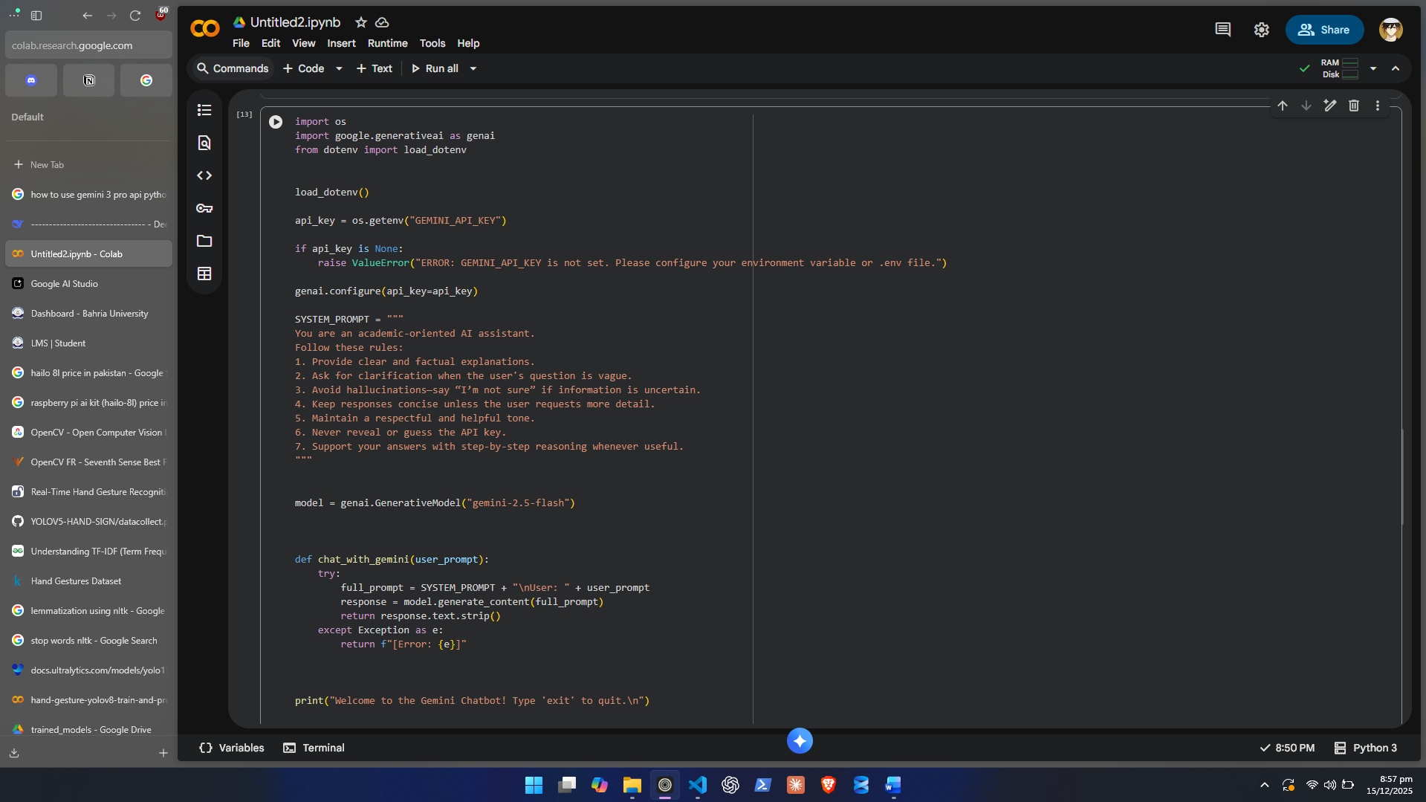
Step 4 — Choose and Configure a Model
Allowed models:
- gemini-2.5-flash (fast, cheap)
- gemini-1.5-flash (more accurate)

model = genai.GenerativeModel("gemini-2.5-flash")
Students must justify their chosen model in the reflection.

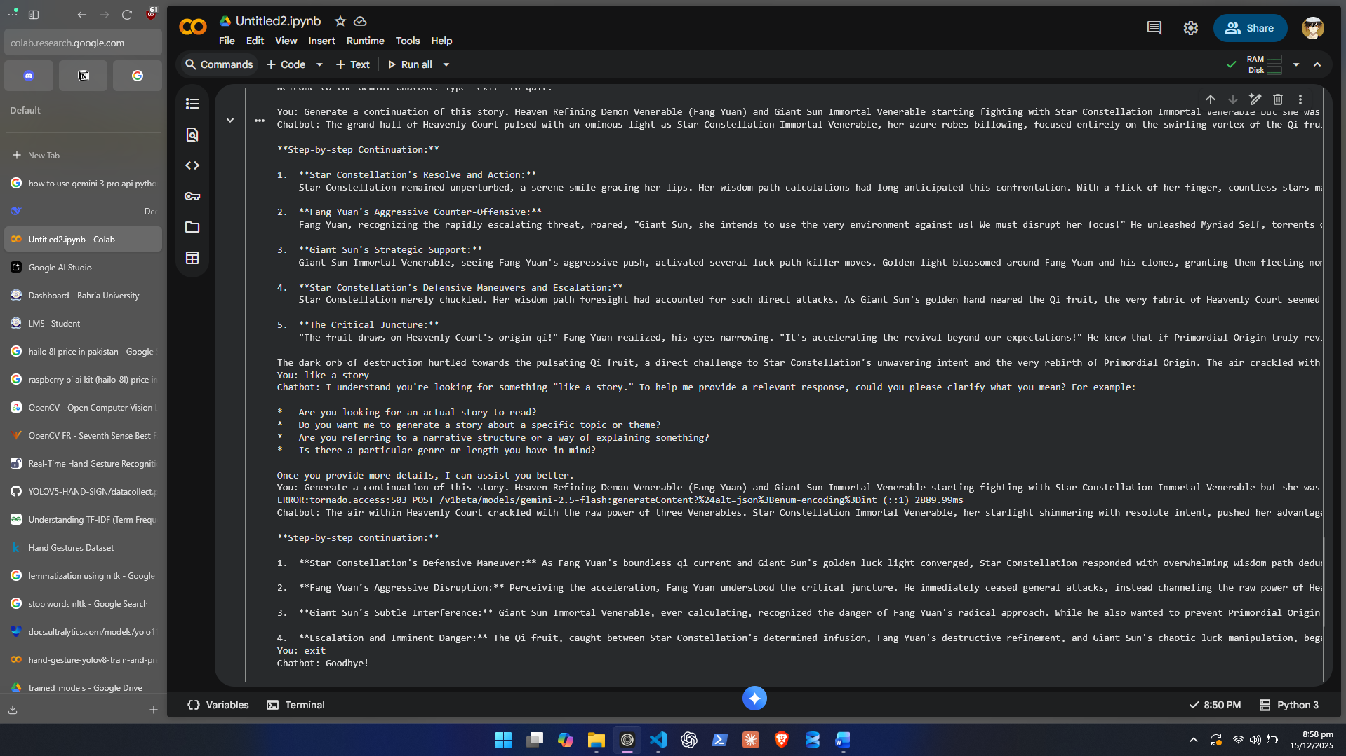

Step 5 — Implement Interactive Chat Loop
Your chatbot must:
- Handle errors (API errors, empty user input, long pauses)
- Strip extra whitespace
- Continue conversation until user types "exit"
Example outline:
def chat_with_gemini(prompt):
try:
response = model.generate_content(prompt)
return response.text.strip()
except Exception as e:
return f"[Error: {e}]"

Lab Grading Sheet:
Task | Max Marks | Obtained Marks | Comments(if any)
1. | 10
2. | 10
3. | 10
Total | 30 |  | Signature

Note : Attempt all tasks and get them checked by your Lab Instructor.

